Title: Training Guide Introduction
Recommended Time: 1 hour
Primary Audience: Patrol Officers
Module Goal: Through classroom instruction and discussion, introduce the training modules included in the ICAT Training Guide.
Required Materials: Digital presentation (Power Point, video); lesson plan
Learning Objectives: At the completion of this module, students will be able to:
  - Describe why this training is important and needed.
  - Describe the key elements and focus of the ICAT Training Guide.
  - Articulate how ICAT is designed to make the job of patrol officers safer and more effective when responding to many critical incidents, in particular those involving subjects in a behavioral crisis who are acting erratically and who are either unarmed or armed with a weapon other than a firearm.

Recommended Time Allocation
 | Unit | Recommended Time  (minutes)
1 | Introduction and welcome | 10
2 | Why this training? | 30
3 | What the training covers | 20
Total |  | 60

Table of Contents

- Introduction and welcome 3
- Why this training? 4
- What the training covers 8

- Introduction and welcome

Recommendation

One way to open this Module is to engage the class in a brief, facilitated discussion on the big-picture issues confronting policing today. This can break the ice and get people talking about the difficult issues facing police today. Here is a possible example.
  - Welcome students – lead a facilitated discussion
    - What is the biggest issue facing law enforcement today? What are we getting the most criticism about?
      - Use of force
      - Breakdown of police-community trust
    - Is that criticism fair?
      - In some cases, yes. But in others, probably not.
      - There is a “new normal” – a controversial incident in one jurisdiction can affect all of law enforcement
    - As a profession, can we do some things differently? Should we strive to do better?
    - That’s the backdrop for this training
      - Confronting difficult issues facing law enforcement
      - Exploring options on how to make your job safer and more effective
  - Go over ground-rules
    - Discussion and participation … this is “hands-on” training – in the classroom and in scenarios
    - Be open-minded to new concepts
    - Be respectful of one another and others’ ideas

Recommendation

To demonstrate executive-level support for ICAT, it is recommended that the agency chief executive deliver a welcome message, either in person or via video.
  - Welcome message from the chief [OPTIONAL]
Slides & Notes

SLIDE #1
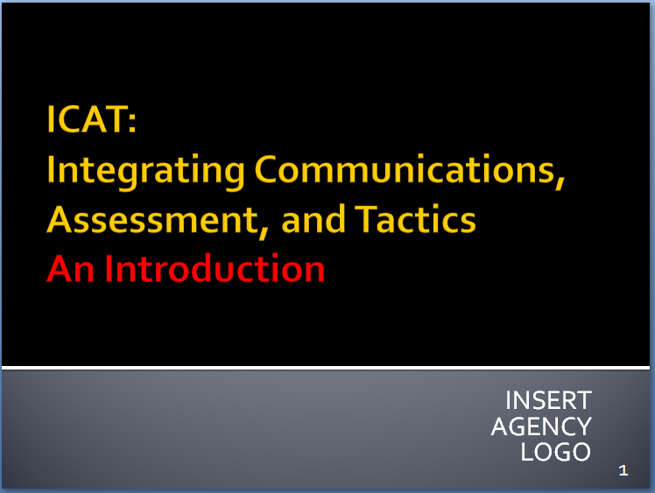

SLIDE #2
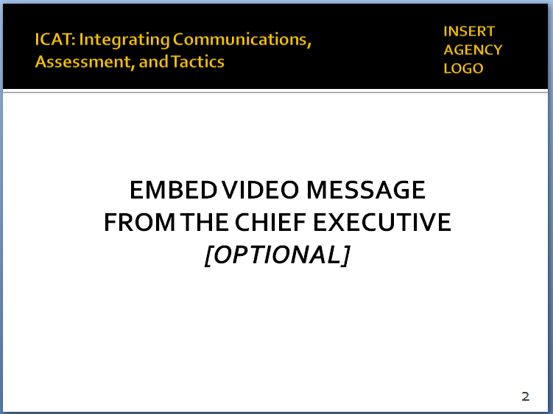

The chief’s message could touch on the ethical foundation of police work, why it’s important to confront difficult issues and how this training can help.

- Why this training?
Instructor Notes

SLIDE #3
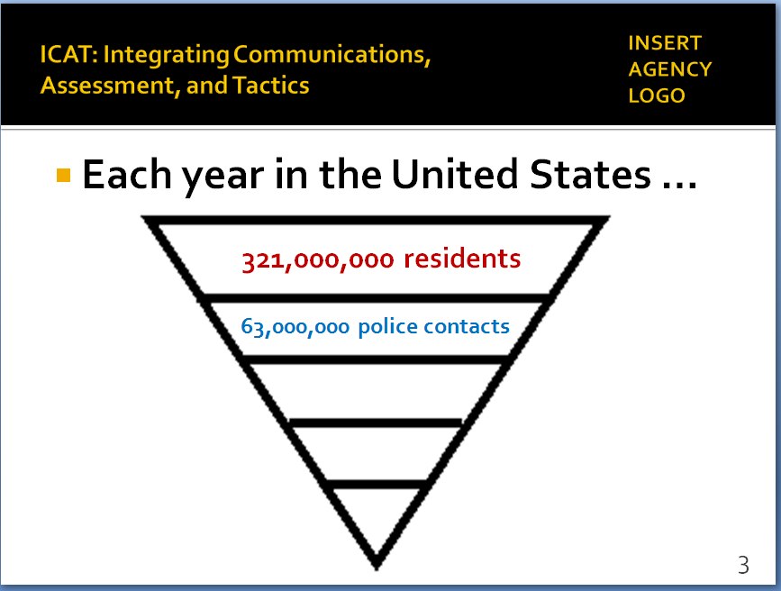

SLIDE #4
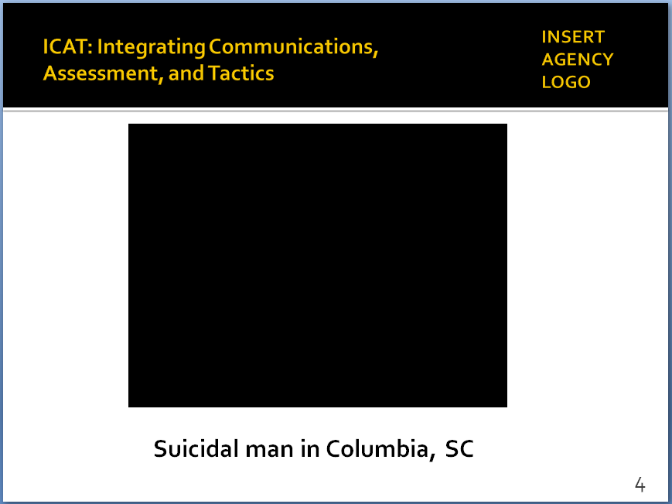
Video also available at https://www.youtube.com/watch?v=58FfkuJZRJE

Additional background: http://www.thestate.com/news/local/article102000562.html

  - First, it’s important to put these issues in some context
    - Approximately 321 million people in the U.S.
    - Each year, about 63 million face-to-face contacts with the police – half are traffic stops, most are “routine”
    - But there are other, more complicated encounters … let’s take a quick look at one such encounter

Recommendation

Two reminders prior to showing this and other videos:
- Set up the video; provide some background information and context.
- Remind students that the videos are not meant to be “good” and “bad” examples; the purpose is not to judge or second-guess the officers’ actions or render a grade. Rather the videos illustrate the real-world challenges officers face. The purpose is to generate discussion on how these challenges might be handled as safely and effectively as possible.

In every video, there will be elements or actions that students will have problems with. That’s fine; none of the videos is “perfect.” Ask students to focus on the “teaching moments” or “lessons learned” based on the Training Guide.
  - Columbia, SC video
    - September 10, 2016 – 0345 hours
    - Officers and EMS workers respond to a man sitting on a bridge guardrail, feet dangling over the highway
    - Show video
    - Lead a brief discussion: possible questions ….
      - Do we see enough videos like this on the news?
      - Is that representative of many of the 63 million contacts officers have with citizens each year?
      - Caring … compassionate … protecting life
      - Solid communications skills, tactics, teamwork (we’ll touch on those throughout this training)
      - That’s what much of policing in the U.S. is all about – important to remember that

- Some additional context
Instructor Notes

SLIDE #5
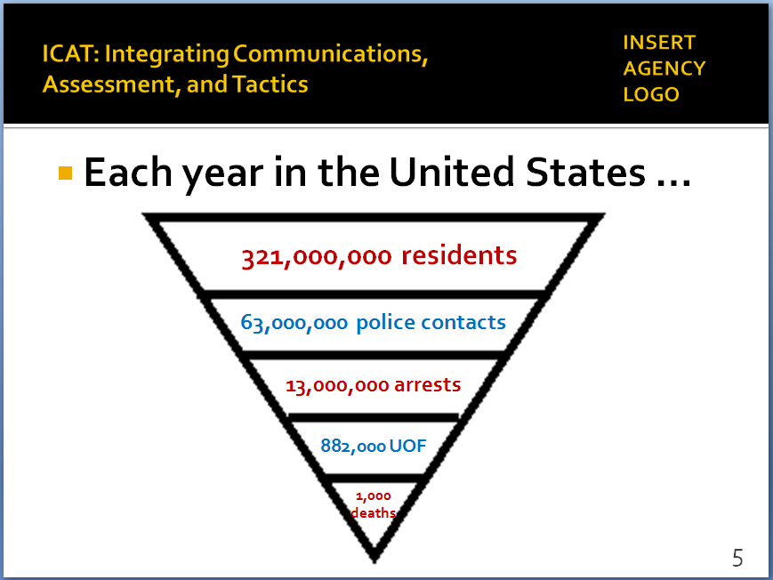

These figures come from a database of fatal officer-involved shootings maintained by the Washington Post. For details see https://www.washingtonpost.com/graphics/national/police-shootings-2016/
Because the federal government has not begun collecting comprehensive use-of-force data (that begins in 2017), we have to rely on open-source information collected by the news media.

Additional background on the incident: http://www.stltoday.com/news/local/crime-and-courts/st-louis-police-release-video-audio-of-deadly-police-shooting/article_9326e02a-2a60-5baa-b63a-9c77b8b81bab.html

SLIDE #6
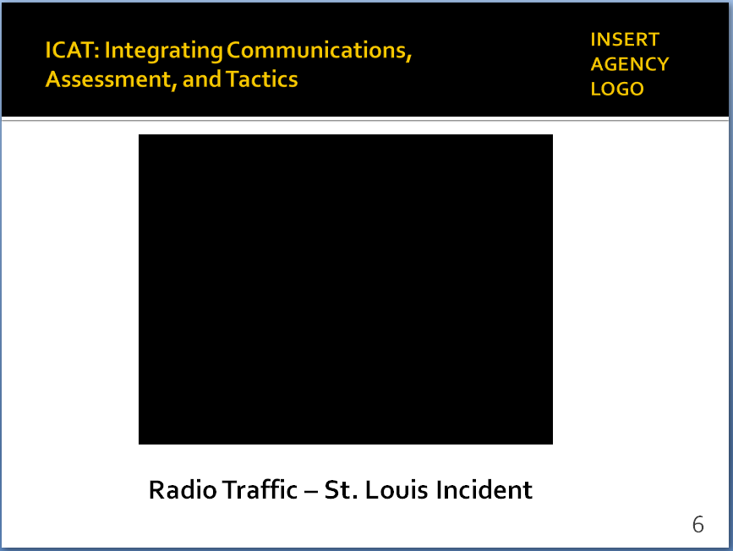
Also available at:
http://www.stltoday.com/online/audio-and-video-evidence-in-kajieme-powell-shooting/collection_b051817e-88bf-5b97-b09c-524e98538ad4.html

    - Of those 63 million contacts each year …
  - About 13 million arrests (FBI: 2015)
  - Estimated 882,000 instances in which police use some level of force (approximately 1.4% of all encounters) – most involve low levels of force
  - Approximately 1,000 fatal uses of force a year
- Bottom line: each day, police officers handle hundreds of thousands of calls for service – they do so professionally, often heroically and without force
  - Of those 1,000 deadly force cases a year, more than 60% involve subjects with firearms – officers have very few options in these situations
  - This training focuses on the remaining 35% (people with knives, blunt objects, etc.) … these are challenging, often dangerous encounters, but ones where officers often have more options
- Let’s take a look at one example ….

Recommendation

Again, remember to …
- Set up the video; provide some background information and context.
- Remind students that the videos are not meant to be “good” and “bad” examples; the purpose is not to judge or second-guess the officers’ actions or render a grade. Rather the videos illustrate the real-world challenges officers face. The purpose is to generate discussion on how these challenges might be handled as safely and effectively as possible.

- Background on the call
      - Happened in St. Louis, 10 days after Ferguson
      - Two calls to 9-1-1 reporting a male had taken drinks from a convenience store and was pacing in front of the store with a knife
      - Play 9-1-1 calls and radio traffic (4 audio files)
    - The incident was captured on cell phone video
Instructor Notes
SLIDE #7
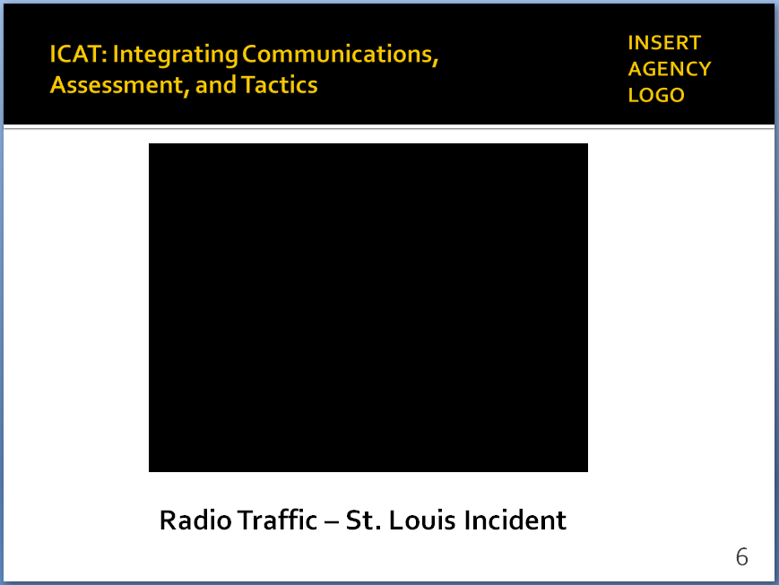
Video also available at https://www.youtube.com/watch?v=FsIlLKOya3c

SLIDE #8
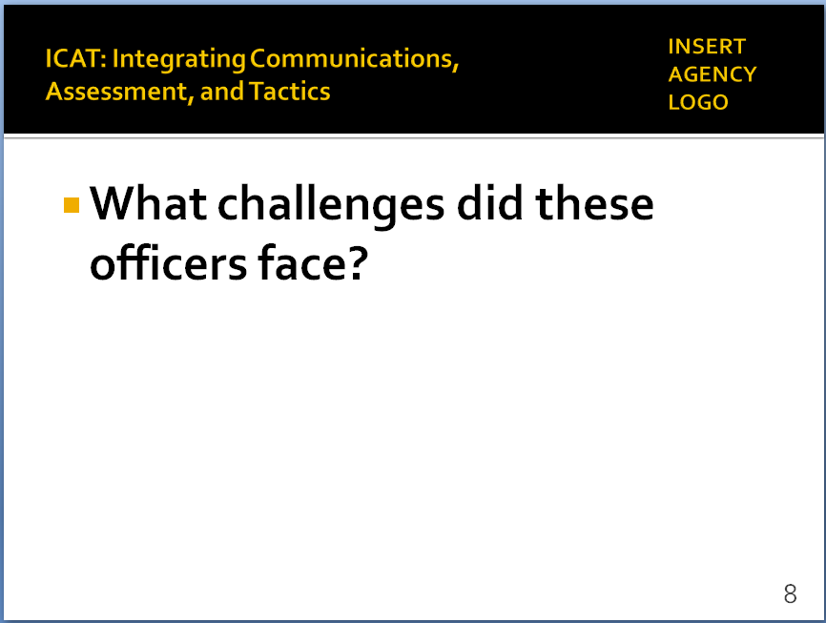

SLIDE #9
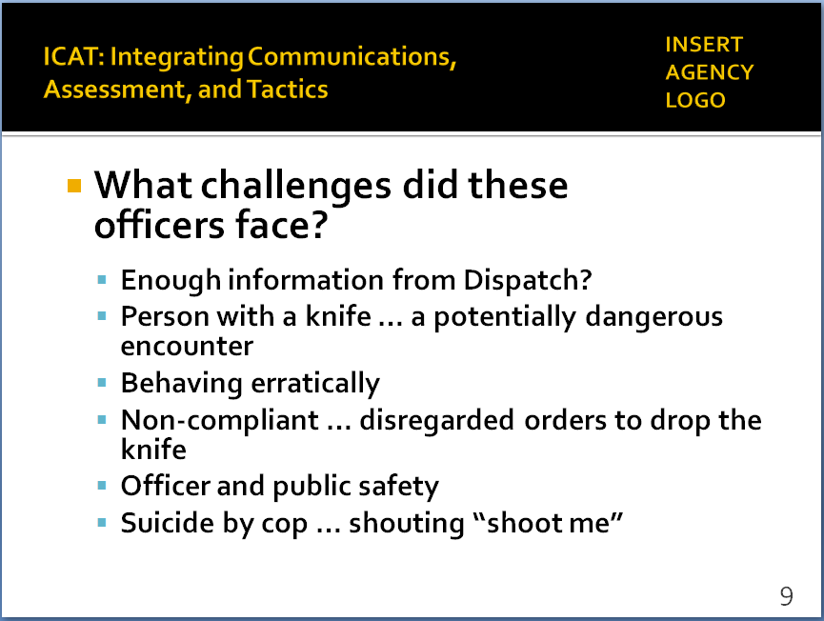

SLIDE #10
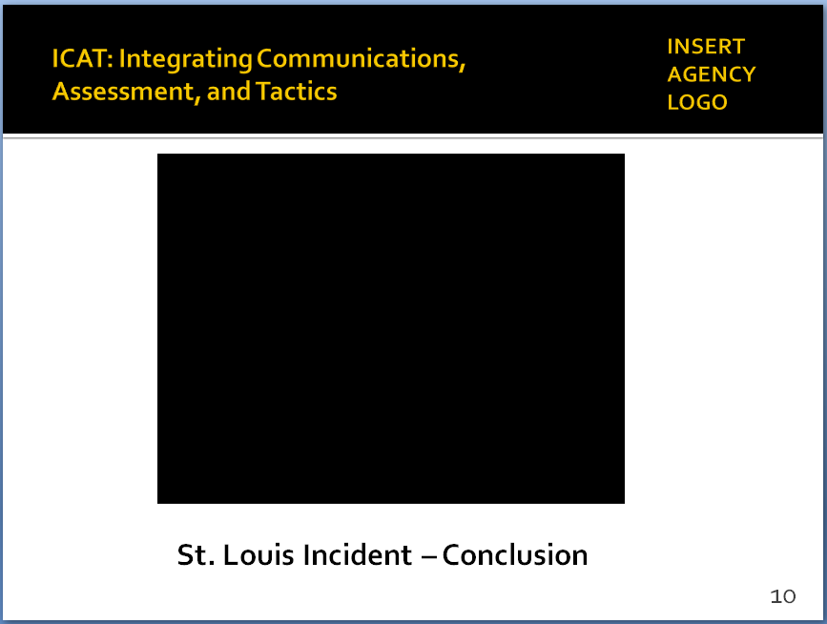

Video also available at https://www.youtube.com/watch?v=2ImlYme93Po

      - Play video
      - [NOTE: this video stops right before officers shoot]
- What were these responding officers faced with?
Lead a brief facilitated discussion (Slide #8)
Then, summarize – (Slide #9)
  - A complex, dynamic event
  - Did officers get enough information from Dispatch?
  - Person with a knife – potential danger to officers and public
  - Person behaving erratically
      - What does his behavior tell us?
      - Was this person in behavioral crisis?
      - (Turns out subject had history of mental illness)
- Person was non-compliant
      - Disregarded orders to “drop the knife?”
      - When that fails, what else can we say?
- Officer and public safety
      - Did officers create and maintain a safe distance?
      - Adequate cover?
      - What about the safety of bystanders?
- “Suicide by cop”
- Man shouted “shoot me”
- What does that tell us? And what do we do?
- Let’s see how this incident ended
  - Play video – then lead a brief discussion
  - What else might these officers have done?
  - What additional information/resources would you have wanted?
  - How might you have approached this differently?
  - What outcome would you have wanted?
- These types of encounters are not easy
Instructor Notes

SLIDE #11
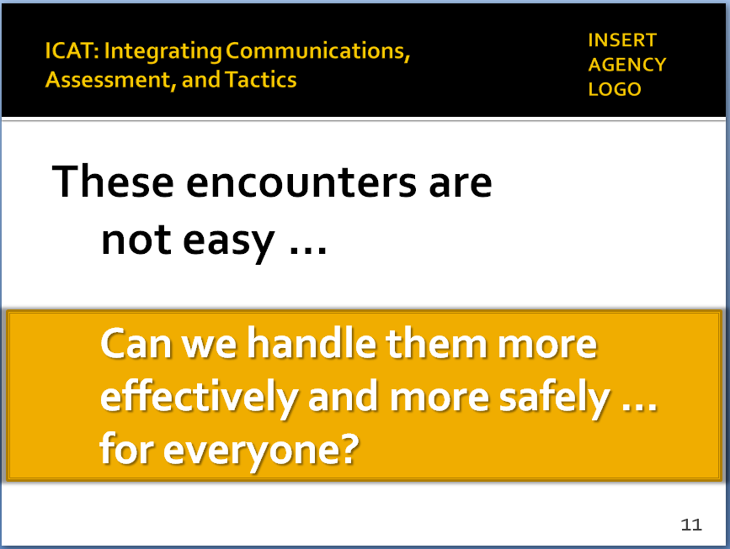

SLIDE #12
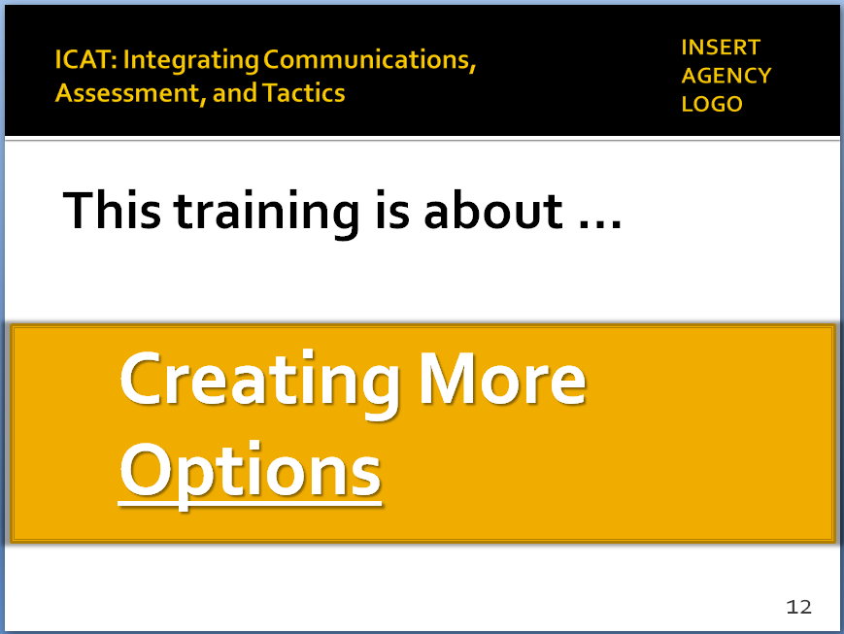

- Traditional police training has taught officers to do essentially what those two officers did – respond immediately, give commands, take charge of the situation, hold your ground
- That approach often worked in the past
- But today, we are dealing with …
  - A more defiant, non-compliant, even disrespectful public
  - Also, a sizeable number of people who are suffering from mental illness or behavioral crisis – people who don’t respond to police commands
  - Bystanders videotaping what we do – adds another “wild card”
- This training challenges some traditional thinking about our response to these types of encounters – and it proposes some new ideas and different approaches
- It asks the question …
- Can we do things differently, more effectively and more safely for everyone – officers, the public and the subject?
- Can we take skills you already have – decision-making, crisis intervention, communications, and sound tactics – and combine them into a more coordinated, effective, team response?
- In short, the training is about creating more options
  - Slowing down situations like this one in St. Louis, whenever possible
  - Giving you more tools and skills to resolve them without having to resort to lethal force, if possible

- What the training covers
  - Skills you already use on a daily basis:
    - Threat assessment
    - Decision making
    - Crisis recognition
    - Communications
    - Physical tactics
  - Integrates those skills … emphasizes the importance of using them in tandem
Instructor Notes

SLIDE #13
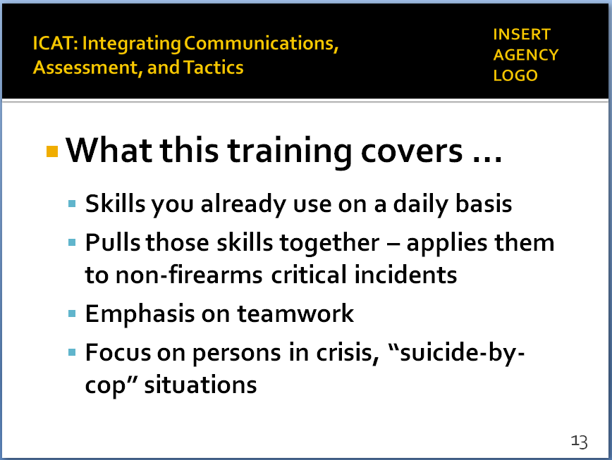

The best athletes continue to practice even though they have played for years. Always looking to perfect their skills, apply them in new ways to new challenges.

SLIDE #14
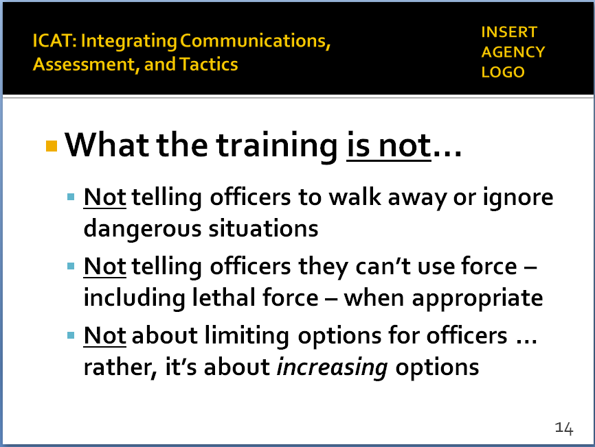

Some view “de-escalation” as taking away options from officers. Need to emphasize this training is designed to increase options.

SLIDE #15
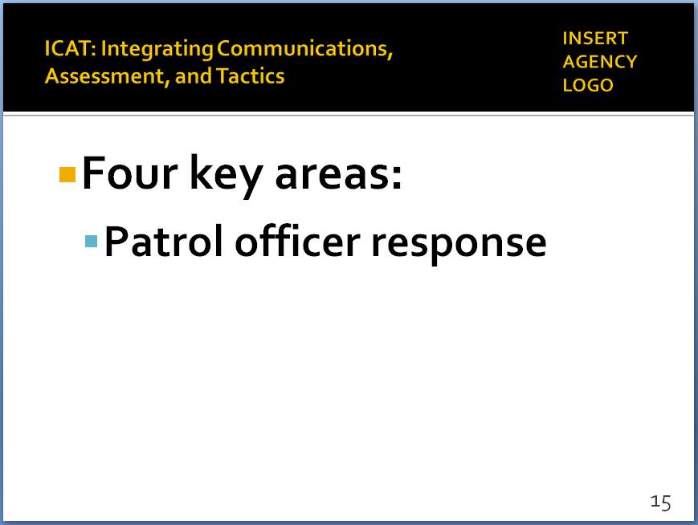

  - Also, the importance of teamwork, responding and working as a team
  - Focuses on situations involving persons with mental illness or in behavioral crisis … plus, “suicide-by-cop” situations
  - What the training is not
    - Not telling officers to walk away from danger
    - Not telling officers you can’t use force, including lethal force, when appropriate
    - Not taking away or limiting options for officers … rather, trying to increase options, which enhances safety
  - Training focuses on four key areas:
    - Patrol officer response (not SWAT or other specialized units)
      - Patrol is typically the first ones on the scene
      - First few minutes of the encounter are often crucial to a safe resolution
      - Goal may be to stabilize the situation – not necessarily resolve it right away
      - Often means “buying time” … so supervisors, additional resources, specialized units can respond

    - Incidents that do not involve firearms
Instructor Notes

SLIDE #16
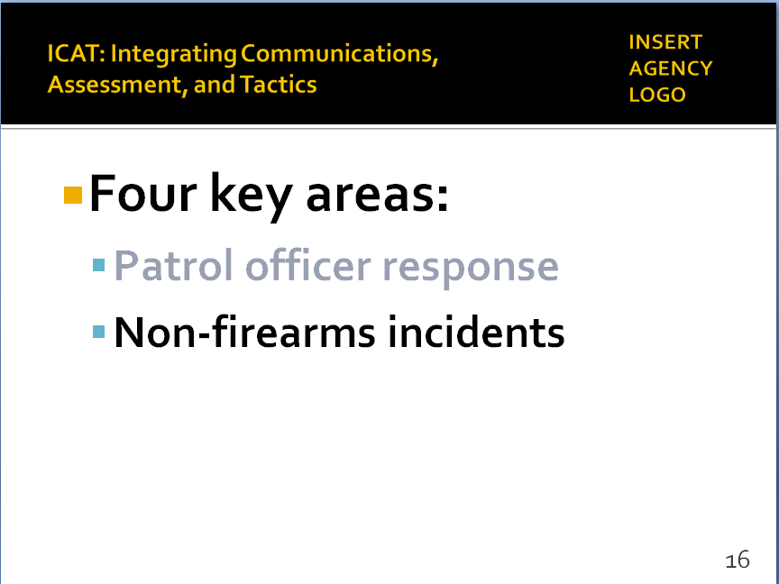

Again, data is from a Washington Post analysis of 2015 fatal officer-involved shootings (see https://www.washingtonpost.com/graphics/national/police-shootings-year-end/) Until the FBI begins collecting this information (scheduled for 2017), the data collected by the news media represent the best we have.

SLIDE #17
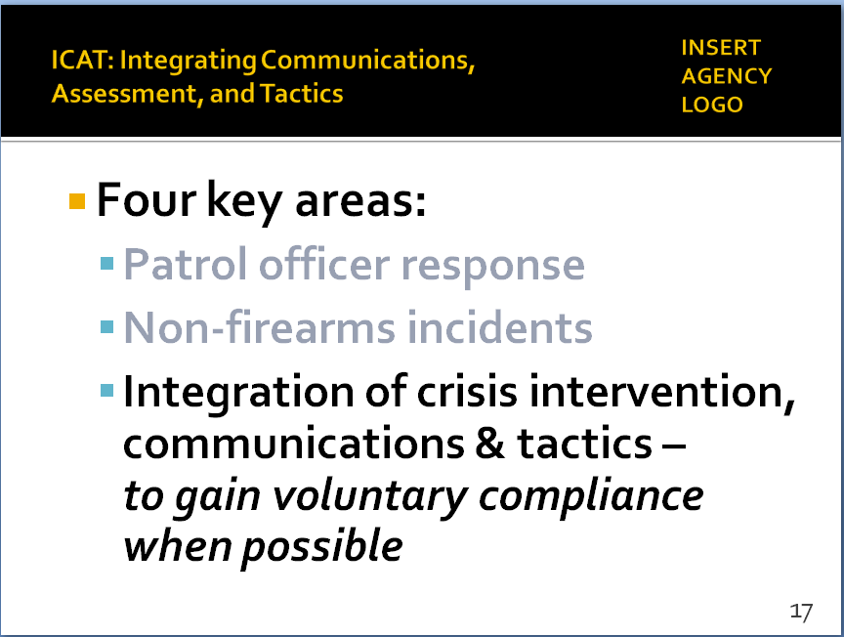

SLIDE #18
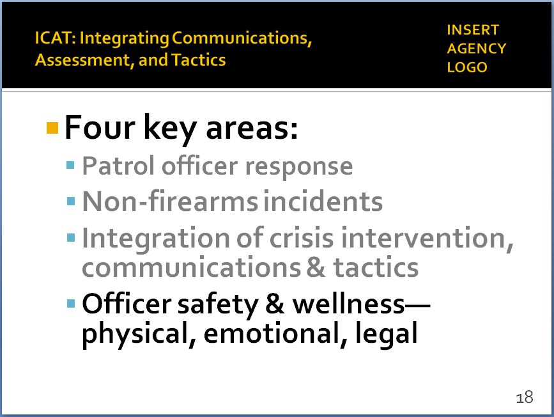

      - About 60% of fatal OISs involve subjects armed with guns. Officers have few options other than lethal force in these instances.
      - Focus of this training is on the remaining cases (300+ in 2015) where the subject is unarmed or armed with a weapon other than a firearm (knife, bat, rocks, etc.)
      - Many of these encounters are dangerous – not minimizing that
      - But some can be safely resolved without the use of deadly force – that’s the focus of this training
    - Integration of skills – crisis recognition/response, communications/negotiations, and tactics
      - Taking key skills from each discipline – then putting them together as part of an overall response strategy
      - Goal: Influence behavioral change to gain voluntary compliance (when possible)– officers need a wide range of skills to confront and stabilize often chaotic scenes
      - Training presents practical alternatives to drawing service weapon and repeatedly shouting “drop the knife”
    - Officer safety and wellness
      - Keeping officers out of harm’s way by providing more options to rushing in on every call
      - Also, protecting officers from the emotional trauma, media scrutiny, and legal troubles that often accompany an officer-involved shooting

  - Bottom line: the purpose of this training is to …
Instructor Notes

SLIDE #19
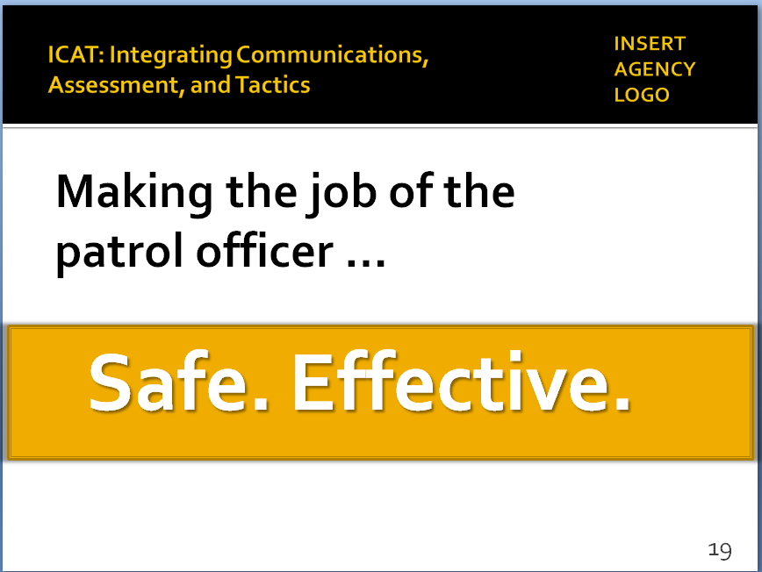

SLIDE #20
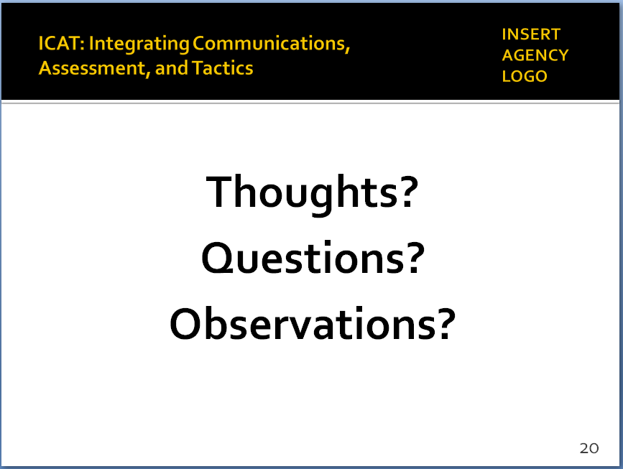

    - Make the job of the patrol officer …
      - Safer – by avoiding situations that put officers in danger and where deadly force may be the only option
      - More effective – by providing officers with more options and more opportunities to achieve safe and peaceful outcomes for everyone
      - Make sure you go home safely … the public goes home safely … and the subjects we deal with can go “home” as well (or to jail or treatment, as the case may be).
    - When we do that, we also build public trust and confidence in the police
      - Demonstrate that we are a profession that strives for the safest outcomes in every encounter
      - That we are committed to the sanctity of all human life
      - All of which gets to the heart of our mission, ethics and values – what we stand for as officers and as a profession
- Thoughts? Questions? Observations?

